 | Summer 2018
 | Triage  The newsletter of Wyndham House Surgery  Phone: 01392 860034  Email: wyndhamhouse.surgery@nhs.net  Website: www.wyndhamhousesurgery.co.uk
st 2015

Dr Jeff Solman, GP
Many patients will remember Jeff from when he completed his GP Training at Wyndham House a couple of years ago. We are delighted that he has returned to a permanent role at Wyndham House. He also works in a senior position at the RD&E A&E Department. He is very happy to perform minor surgery and joint injections.
Staff Update

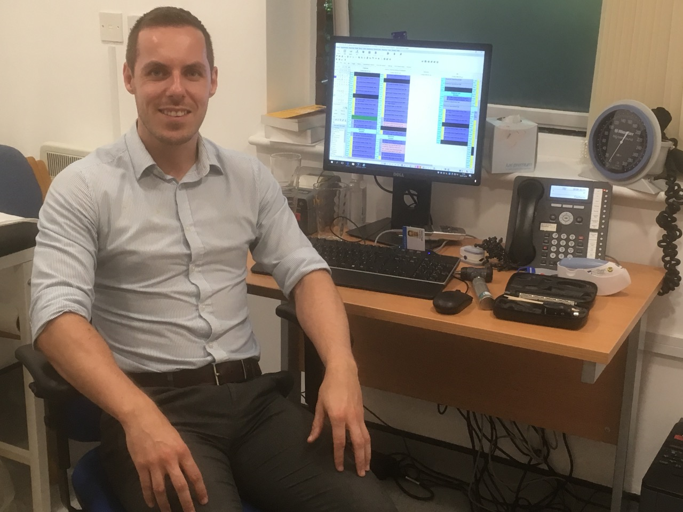

B
Introducing Dr Woodfield
We are delighted to announce that Dr Catherine Burkill has become a mother for the second time with the addition of her daughter Emma to the family in January. Catherine will be on maternity leave until October and in the interim Dr Bethan Woodfield will be covering her sessions in the practice. Bethan grew up in Cornwall and completed her GP training in a rural GP practice in Devon very similar to Wyndham House.

Photo of Bethan??

Elaine Rolfe – Practice Nurse
Elaine is an extremely experienced Practice Nurse with extended qualifications in Diabetes, Chronic Obstructive Pulmonary Disease and Travel Medicine. We are thrilled that she has chosen to bring her considerable skills to Wyndham House. Elaine is in the process of setting up a Travel Medicine service that will combine her knowledge and advice regarding travel vaccines with our Dispensary providing medication and medical equipment of use to those patients going abroad.
Emma Stone, GP
(covering Dr Catherine Burkill’s sabbatical leave)
Emma is joining us for the next year to cover Catherine’s sessions whilst she is in New Zealand. She has just returned from a sabbatical herself, spending the last year in Melbourne. Her husband is starting as an Orthopaedic Consultant at the RD&E and so they are returning from Australia to set up home with their young family in Devon.

Hayley Pollard – Receptionist/Dispenser
In anticipation of Helen Gill’s retirement after 32 years at Wyndham House we are delighted that Hayley has joined our team. She will be working in tandem with Helen to acquire her knowledge and skills as well as spending time in Dispensary. We are sure patients will get to know her friendly and welcoming smile very quickly.
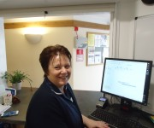
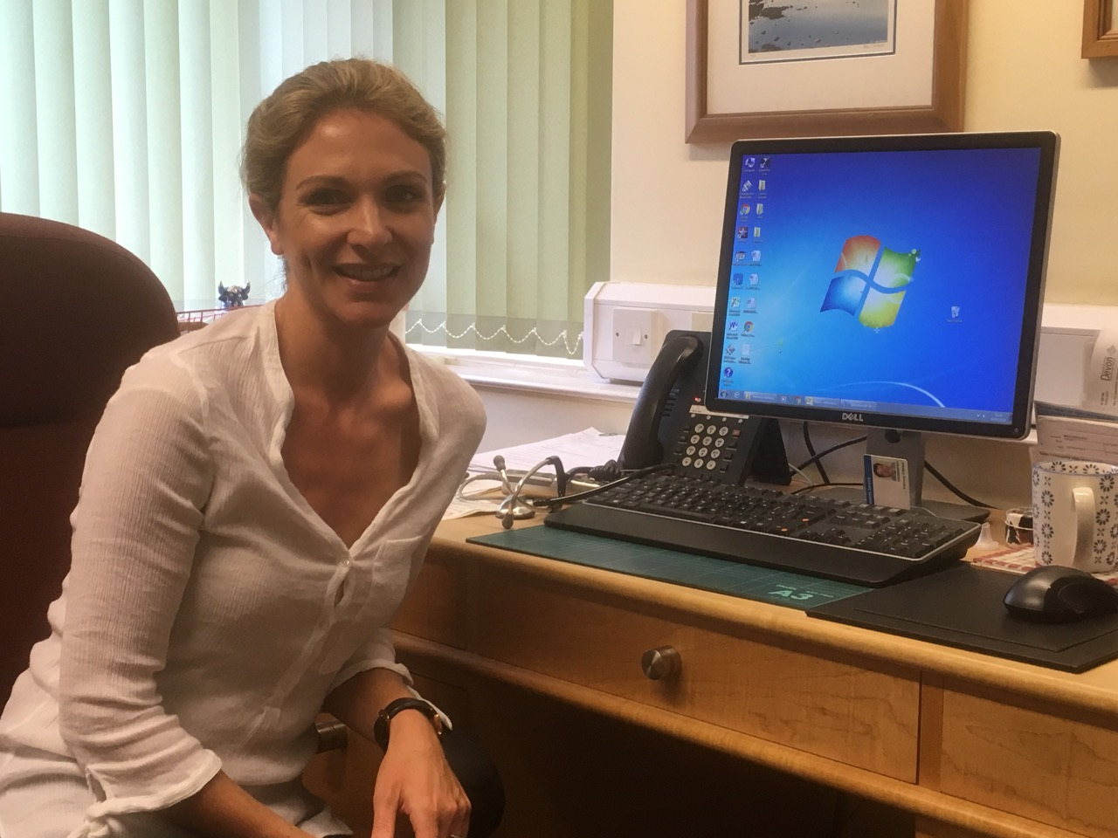
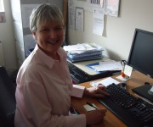
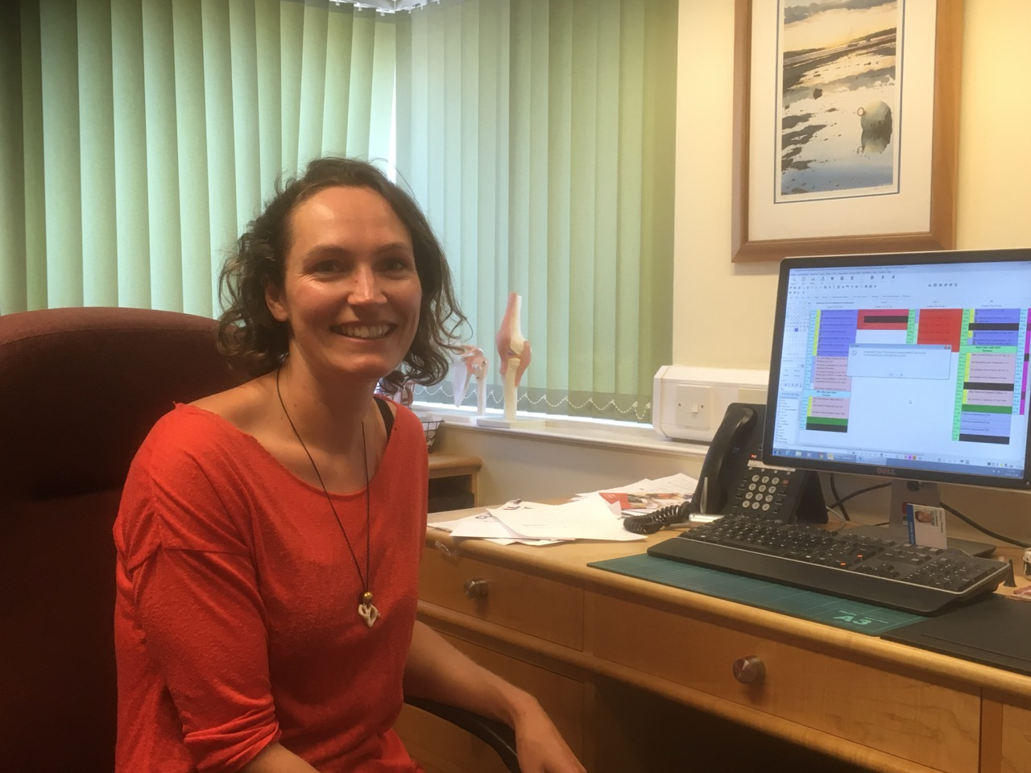
Dr Harriet Burn – GP Registrar
Harriet is joining us to complete her final year of GP training. Following her first two years at the RD&E and with a practice in Exeter she had the opportunity to go abroad for 12 months. She spent this working in a refugee camp in Greece and also as the doctor to a team of cyclists who rode from Cairo to Cape Town.

