**Barnes Room Timetable**

Monday: Jigsaws, board games and computer access.

Tuesday: A community cafe. Light refreshments.

Wednesday: Art, open session for all abilities, run by local artists.

Thursday: To be arranged

Friday: Respite care day. Can be used as a pop in or carers can leave their loved one so that they can have some free time and have a break from 24/7 caring. This is a free service as are all the activities in the Barnes room with the exception of the Community Cafe!

These are ‘Drop in’ Clinics so no need to book an appointment, just come along on the appropriate day.

This year we will be running our Flu Clinics differently. We will have two Saturday morning sessions in the surgery with tea and coffee afterwards in Room4U.

The first clinic will be on Saturday 20th October and will run from 9am to 1pm. This will be for all patients over 75 years and also those of all ages at risk due to Diabetes, Asthma and COPD.

The second clinic will be on Saturday 10th November for those aged 65 – 75 years.

Children aged 2 – 4 yrs are welcome on either Saturday morning. All school age children will be vaccinated in their Primary School.

rimary School

**Flu Clinics 2018 – Saturday 20th October and Saturday 10th November**



The conversion of the old toilet block into Room4U came to fruition on Saturday 7th July. Jenny Roach spearheaded the project whose outcome is a fantastic community resource that will provide help, support and care to many for years to come.

There are two rooms: the Barnes Room will have daily activities and the smaller treatment room has a massage couch that also doubles as a chair for foot care. Different therapists will offer a range of treatments

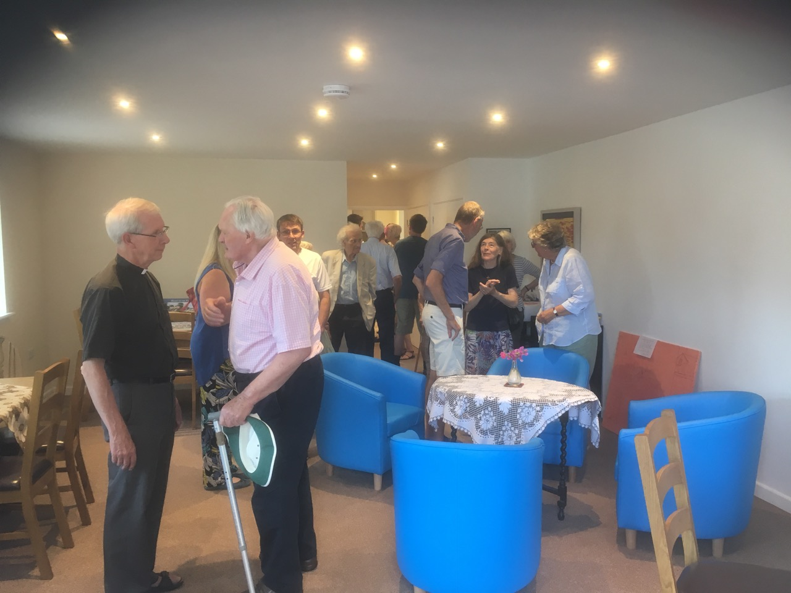

**Silverton Room4U**