
Wyndham House Surgery
Patient Participation Group

The Patient Participation Group is launching its’ first survey in June.

We want to find out how best the surgery can communicate with you,
and also we would like to hear your experience of the dispensary.

The survey is anonymous, and there are only 14 questions.

Follow this link

PPGsurvey-online-June2026

or scan this QR code
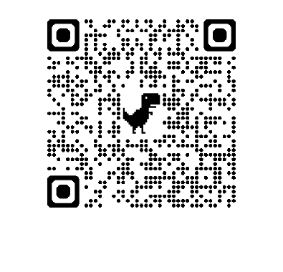
or ask at reception for a paper copy

Thank You

